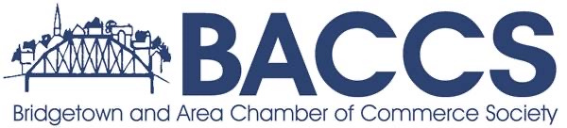
AGENDA
October 16th 2025
6:30 pm Bridgetown Library
1. Call to order/ Attendance
2. Agenda
Additions
3. Review of minutes from September Meeting
Errors and Omissions
Approval of minutes
Business Arising
4. Committee Reports: (5 Minutes Each)
Finance/Treasurer
VIC-Tourism
Development Committee
Membership
Light Up the Town
Commerce Committee
6. NEW BUSINESS:
BACCS Meet and Greet

Next Meeting November 20th 2025 6:30 Bridgetown Legion

