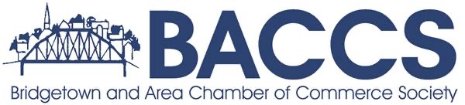
AGENDA
May 21st 2026
6:30pm Bridgetown Library
1. Call to order/ Attendance
2. Agenda
Additions
3. Guest Speakers: Deb Ryan, Laura Hamilton County Of Annapolis
4. Review of minutes from AGM, March and April meetings
Errors and Omissions
Approval of minutes
Business Arising
5. Committee Reports: (5 Minutes Each)
o Finance
o VIC-Tourism
o Development Committee * Fund request Queen St
o Membership
o Light Up the Town
6. NEW BUSINESS:

Next Meeting July 16th 6:30 Bridgetown Library

